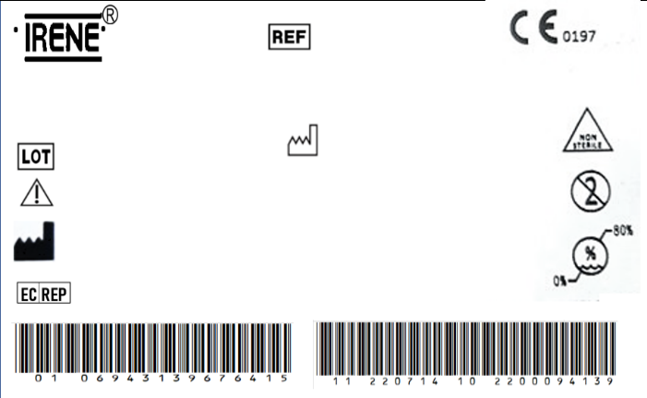

Humeral Interlocking Nail (Cannulated)

0706.201.017XN

2300004244

2023/05/5

REGISTRO SANITARIO

5753-DME-1018

IMPORTADO Y DISTRIBUIDO POR ORTOMAX- PINEDA CORAL JAIRO DARIO

The implante should be sterilized before surgery.

TianJin ZhengTian Medical Instrument Co., ltd.

No. 318, Jingyi Road

Airport Economic Zone 300308 TianJin P.R. China

Bricon GmbH

EisenBahnstrasse 100, 78573 Wurmlingen, Germany

Spec

Ф8.0×260mm



Humeral Interlocking Nail (Cannulated)

0706.201.017XN

2300004244

2023/05/5

REGISTRO SANITARIO

5753-DME-1018

IMPORTADO Y DISTRIBUIDO POR ORTOMAX- PINEDA CORAL JAIRO DARIO

The implante should be sterilized before surgery.

TianJin ZhengTian Medical Instrument Co., ltd.

No. 318, Jingyi Road

Airport Economic Zone 300308 TianJin P.R. China

Bricon GmbH

EisenBahnstrasse 100, 78573 Wurmlingen, Germany

Spec

Ф8.0×260mm



Humeral Interlocking Nail (Cannulated)

0706.201.017XN

2300004244

2023/05/5

REGISTRO SANITARIO

5753-DME-1018

IMPORTADO Y DISTRIBUIDO POR ORTOMAX- PINEDA CORAL JAIRO DARIO

The implante should be sterilized before surgery.

TianJin ZhengTian Medical Instrument Co., ltd.

No. 318, Jingyi Road

Airport Economic Zone 300308 TianJin P.R. China

Bricon GmbH

EisenBahnstrasse 100, 78573 Wurmlingen, Germany

Spec

Ф8.0×260mm



Humeral Interlocking Nail (Cannulated)

0706.201.017XN

2300004244

2023/05/5

REGISTRO SANITARIO

5753-DME-1018

IMPORTADO Y DISTRIBUIDO POR ORTOMAX- PINEDA CORAL JAIRO DARIO

The implante should be sterilized before surgery.

TianJin ZhengTian Medical Instrument Co., ltd.

No. 318, Jingyi Road

Airport Economic Zone 300308 TianJin P.R. China

Bricon GmbH

EisenBahnstrasse 100, 78573 Wurmlingen, Germany

Spec

Ф8.0×260mm



Humeral Interlocking Nail (Cannulated)

0706.201.017XN

2300004244

2023/05/5

REGISTRO SANITARIO

5753-DME-1018

IMPORTADO Y DISTRIBUIDO POR ORTOMAX- PINEDA CORAL JAIRO DARIO

The implante should be sterilized before surgery.

TianJin ZhengTian Medical Instrument Co., ltd.

No. 318, Jingyi Road

Airport Economic Zone 300308 TianJin P.R. China

Bricon GmbH

EisenBahnstrasse 100, 78573 Wurmlingen, Germany

Spec

Ф8.0×260mm



Humeral Interlocking Nail (Cannulated)

0706.201.017XN

2300004244

2023/05/5

REGISTRO SANITARIO

5753-DME-1018

IMPORTADO Y DISTRIBUIDO POR ORTOMAX- PINEDA CORAL JAIRO DARIO

The implante should be sterilized before surgery.

TianJin ZhengTian Medical Instrument Co., ltd.

No. 318, Jingyi Road

Airport Economic Zone 300308 TianJin P.R. China

Bricon GmbH

EisenBahnstrasse 100, 78573 Wurmlingen, Germany

Spec

Ф8.0×260mm



Humeral Interlocking Nail (Cannulated)

0706.201.017XN

2300004244

2023/05/5

REGISTRO SANITARIO

5753-DME-1018

IMPORTADO Y DISTRIBUIDO POR ORTOMAX- PINEDA CORAL JAIRO DARIO

The implante should be sterilized before surgery.

TianJin ZhengTian Medical Instrument Co., ltd.

No. 318, Jingyi Road

Airport Economic Zone 300308 TianJin P.R. China

Bricon GmbH

EisenBahnstrasse 100, 78573 Wurmlingen, Germany

Spec

Ф8.0×260mm



Humeral Interlocking Nail (Cannulated)

0706.201.017XN

2300004244

2023/05/5

REGISTRO SANITARIO

5753-DME-1018

IMPORTADO Y DISTRIBUIDO POR ORTOMAX- PINEDA CORAL JAIRO DARIO

The implante should be sterilized before surgery.

TianJin ZhengTian Medical Instrument Co., ltd.

No. 318, Jingyi Road

Airport Economic Zone 300308 TianJin P.R. China

Bricon GmbH

EisenBahnstrasse 100, 78573 Wurmlingen, Germany

Spec

Ф8.0×260mm



Humeral Interlocking Nail (Cannulated)

0706.201.017XN

2300004244

2023/05/5

REGISTRO SANITARIO

5753-DME-1018

IMPORTADO Y DISTRIBUIDO POR ORTOMAX- PINEDA CORAL JAIRO DARIO

The implante should be sterilized before surgery.

TianJin ZhengTian Medical Instrument Co., ltd.

No. 318, Jingyi Road

Airport Economic Zone 300308 TianJin P.R. China

Bricon GmbH

EisenBahnstrasse 100, 78573 Wurmlingen, Germany

Spec

Ф8.0×260mm



Humeral Interlocking Nail (Cannulated)

0706.201.017XN

2300004244

2023/05/5

REGISTRO SANITARIO

5753-DME-1018

IMPORTADO Y DISTRIBUIDO POR ORTOMAX- PINEDA CORAL JAIRO DARIO

The implante should be sterilized before surgery.

TianJin ZhengTian Medical Instrument Co., ltd.

No. 318, Jingyi Road

Airport Economic Zone 300308 TianJin P.R. China

Bricon GmbH

EisenBahnstrasse 100, 78573 Wurmlingen, Germany

Spec

Ф8.0×260mm